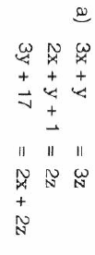
Distribution Assignment 1 (Simultaneous) Distribution Assignment 1 (Simultaneous)
Due Date: ________________________ Due Date: ________________________

1)
1)

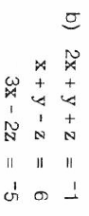

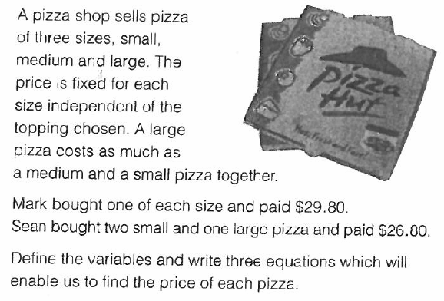
2)
2)

Distribution Assignment 2 (Simultaneous)
Due Date: ________________________
3)
The following set of equations does not have a unique solution.
x + 2y + z = 6 x + 2y – z = 6 x + 3y – z = 4
1)
2)
x – y = 2 2x – y + 3z = – 13 Give geometric description of how x + 2y + z = 2
x – y + z = 0 3x – 2 y + 3z = – 16 these three planes relate to each other. 3x + 7y + z = 9

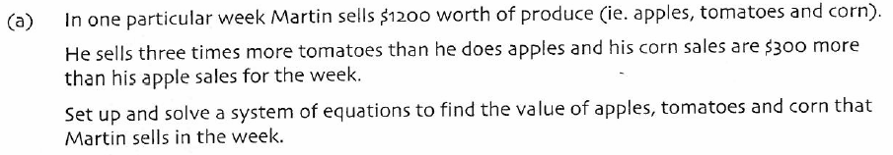
4)

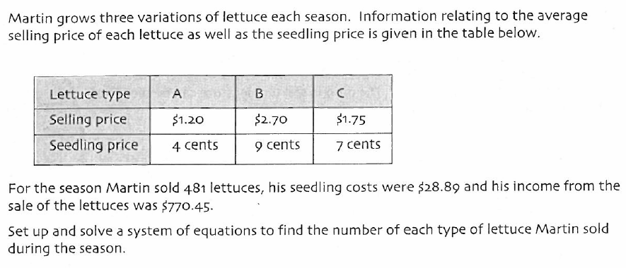
5)

Distribution Assignment 3 (Simultaneous)
Due Date: ________________________
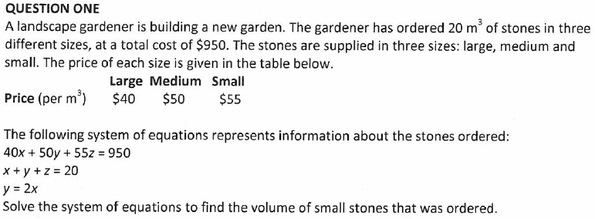

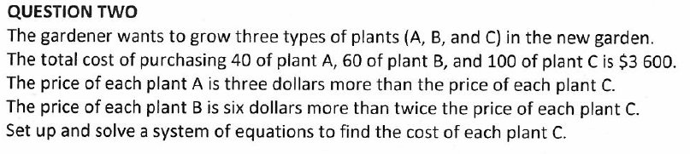

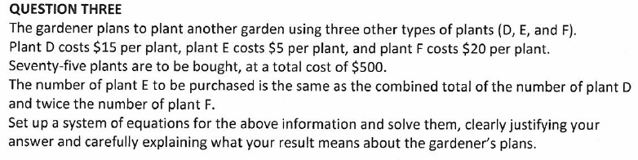

Distribution Assignment 4 (Simultaneous) Distribution Assignment 4 (Simultaneous)
Due Date: ________________________ Due Date: ________________________
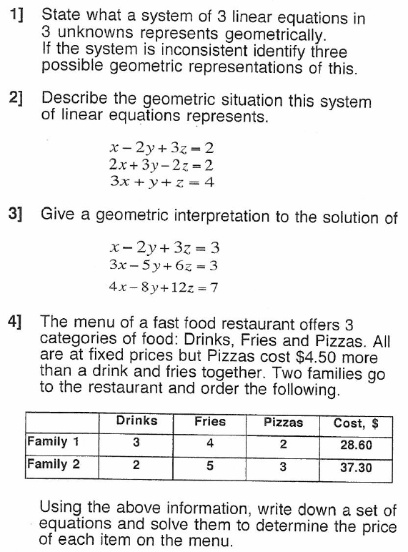

Distribution Assignment 5 (Simultaneous) Distribution Assignment 5 (Simultaneous)
Due Date: ________________________ Due Date: ________________________

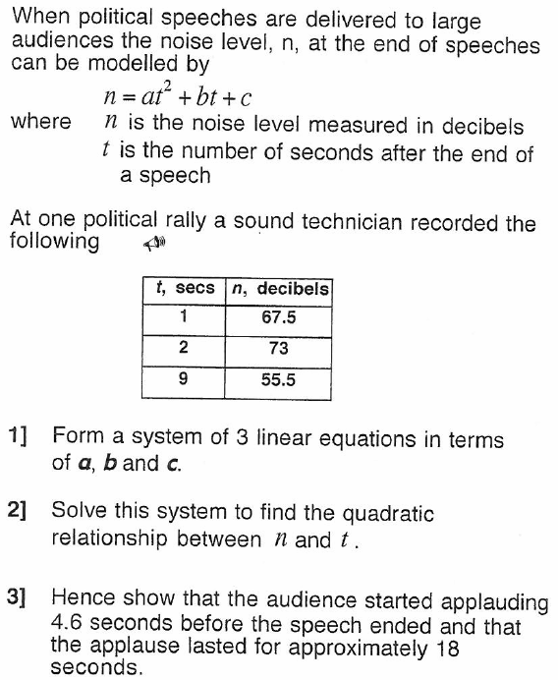

Distribution Assignment 6 (Simultaneous) Distribution Assignment 6 (Simultaneous)
Due Date: ________________________ Due Date: ________________________

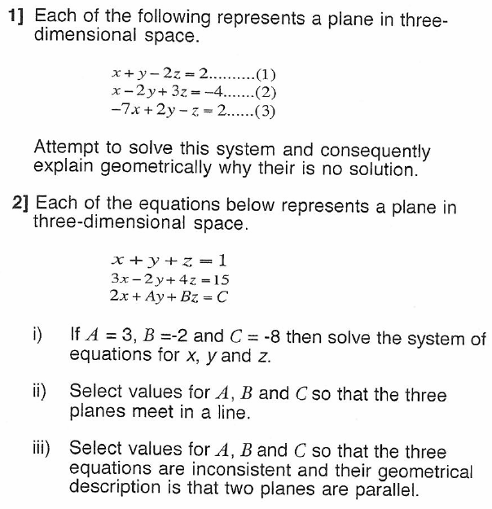

Distribution Assignment 7 (Simultaneous)
Due Date: ________________________
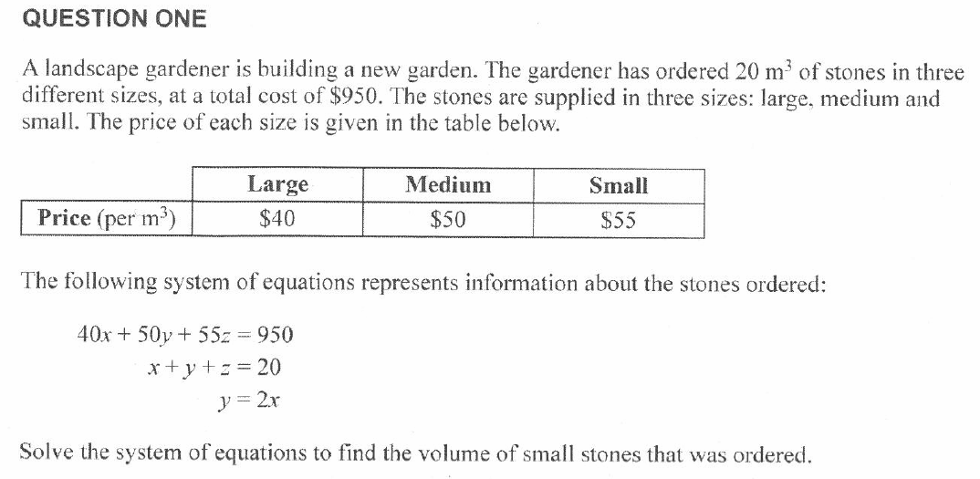

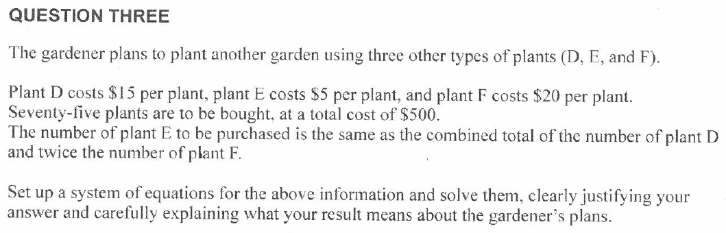

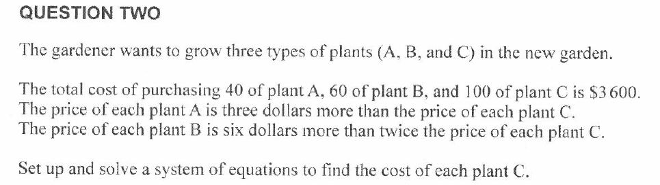

Distribution Assignment 8 (Simultaneous) Distribution Assignment 8 (Simultaneous)
Due Date: ________________________ Due Date: ________________________

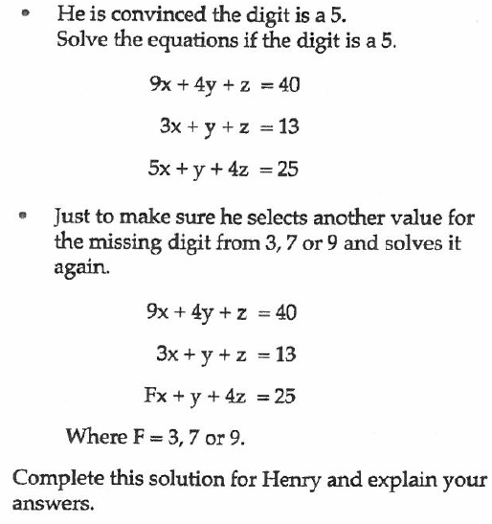

Distribution Assignment 9 (Simultaneous) Distribution Assignment 9 (Simultaneous)
Due Date: ________________________ Due Date: ________________________
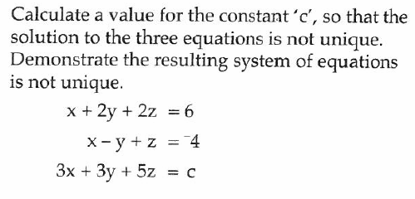
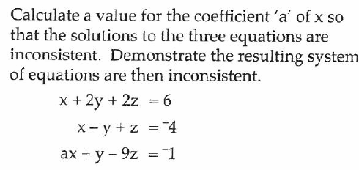
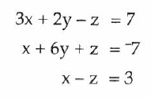
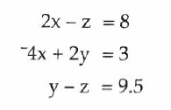
3)
2)
1)
4)
2)
1)

3)

4)

Distribution Assignment 10 (Simultaneous)
Due Date: ________________________

1) (Achieve) Solve this system of equations:
x + y + z = 1 (i)
3x – 2y + 4z = 15 (ii)
2x + 3y – 2z = -8

2) (Merit) In a mathematics competition there are three sections. Each correct answer in section A scores four points, each correct answer in section B scores five marks, and each correct answer in section C scores six marks.

One entrant answered 23 questions correctly, and earned 112 marks altogether. She had 9 more answers correct in sections A and B together than in section C.

a) Form a set of simultaneous equations
b) Solve the equations to find the number of correct questions in section B

(Excellence) For each set of equations below, attempt to solve, and explain geometrically what is happening.

3) x + y + z = 1 4) x + y + z = 2
2x – y + z = 2 3x + 3y + 3z = 15
3x + 2z = 4 2x + 4y – 5z = 6

5) 2x + y – 5z = 1 6) x + y + z = 8
4x - 3y + 2z = 10 x + y + z = 10
2x + 6y - 17z = -7 x + y + z = 13

7) x + y + z = 4
2x + 2y + 2z = 8
3x + 3y + 3z = 12

Distribution Assignment 10 (Simultaneous)
Due Date: ________________________

1) (Achieve) Solve this system of equations:
x + y + z = 1 (i)
3x – 2y + 4z = 15 (ii)
2x + 3y – 2z = -8
2) (Merit) In a mathematics competition there are three sections. Each correct answer in section A scores four points, each correct answer in section B scores five marks, and each correct answer in section C scores six marks.

One entrant answered 23 questions correctly, and earned 112 marks altogether. She had 9 more answers correct in sections A and B together than in section C.

a) Form a set of simultaneous equations
b) Solve the equations to find the number of correct questions in section B

(Excellence) For each set of equations below, attempt to solve, and explain geometrically what is happening.

3) x + y + z = 1 4) x + y + z = 2
2x – y + z = 2 3x + 3y + 3z = 15
3x + 2z = 4 2x + 4y – 5z = 6

5) 2x + y – 5z = 1 6) x + y + z = 8
4x - 3y + 2z = 10 x + y + z = 10
2x + 6y - 17z = -7 x + y + z = 13

7) x + y + z = 4
2x + 2y + 2z = 8
3x + 3y + 3z = 12

