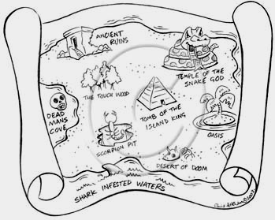
Grid references

Map references are given in 6 digits eg 317 933
The first group is east / west (317)
The second group is north / south reference (933)

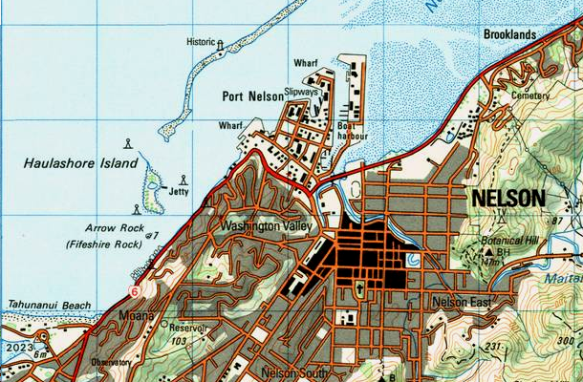
Look for the 31 and 32 on the east/west map scale then divide the interval into ten, and estimate 7
93
31
95
94
92
32
33
34
35

Note the map scale
1 square = 1km

HW
p143 Ex 30.6

Map references are given in 6 digits eg 535 047

The first group is east / west (535)
Look for the 53 and 54 on the east / west map scale then
divide the interval into ten, and estimate 5
The second group is north / south reference (047)
Look for the 04 and 05 on the north/south map scale then
divide the interval into ten, and estimate 7
Gamma (M)
P438 Ex 30.06 ?

If needed note the map scale.

Example House A is at 236 089 (i.e. 236m E, 089m N of a fixed point.)
House B is at 108 211.
- Draw a diagram with A & B on the vertices of a rt ∠ ∆.
- Calculate the distance from A to B.
Gamma (M)
P440 Ex 30.07 ?
- Find the bearing of B from A.

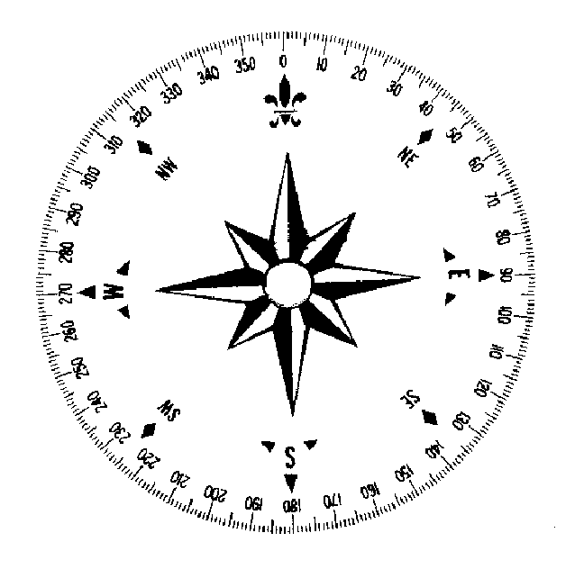
Excellence Example

A yacht leaves a port P (grid reference 315 937) and
sails on a bearing of 306 for3.6 km to buoy B

It then turns and sails to C (grid reference 302 974)
and then returns to port P

How far did the ship sail?
From point C what is the bearing back to P?

