. Exponential Patterns .
1, 2, 4, 8, 16, 32, 64… what do you notice in these patterns?
1, 3, 9, 27, 81, 243…
1, 5, 25, 125, 625, 3125… There is a common……
4, 5, 7, 11, 19, 35, 67…

2⁰ 2¹ 2² 2³ 2⁴ 2⁵ y = 2^{x} Base & Exponent = Exponential Pattern

What does this look like on a graph? Excel Demo
y = 2^{x}
x | y
0
1
2
3
4
5
-1
-2
-3

y = 3^{x}
x | y
0
1
2
3
4
5
-1
-2
-3

y = 5^{x}
x | y
0
1
2
3
4
5
-1
-2
-3

And for negative
‘x’ values?

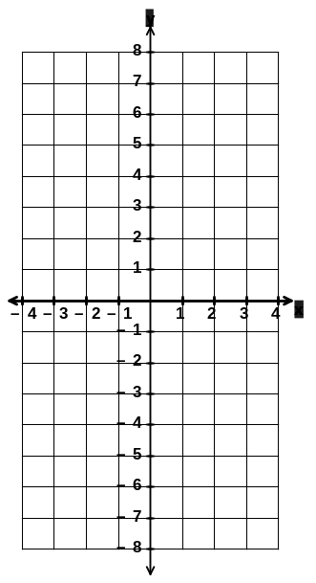

. Exponential Graphs .
Features of the exponential graph? y = A^{x}

Smooth curves Passing through y = 1 At x=1 y=A

Sketch these graphs:

1) y = 4^{x} 2) y = 6^{x}

3) y = 3^{x} + 1 How do we do this?
. Exponential Graphs B .
Vertical translation of exponential graph
y = A^{x} + B
Sketch

y = 2^{x} + 2

y = 2^{x} + 4

y = 2^{x} – 3

y = 2^{x} – 7

y = 3^{x} + 1

y = 5^{x} – 5

y = 4^{x} – 2

