. Histograph / Histogram .

A graphical representation of the distribution of numerical data.
An estimate of the probability distribution of a continuous variable (quantitative variable)
No gaps between ‘bins’ as continuous variable
The area of each bin important
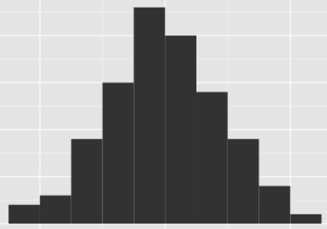
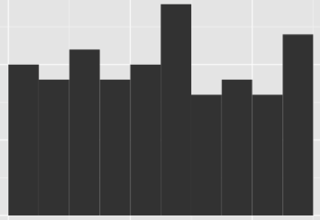
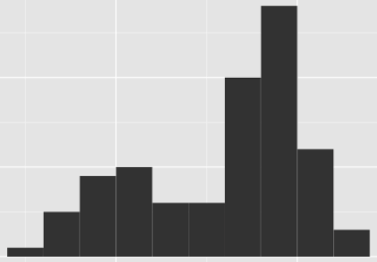
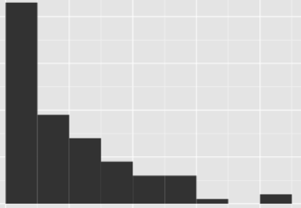

Symmetrical Bimodal Skewed Right Uniform

Unimodal

Grouped data

Measure 4 finger lengths on one hand

Collate class results

http://en.wikipedia.org/wiki/Histogram images
. Data Cards .
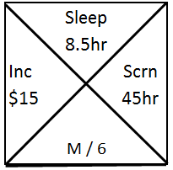
Make a ‘Histograph’ for:

* Average Income /week

* Total Screen time per week

What scale will you need?
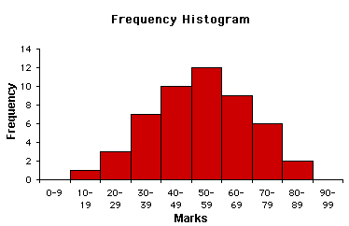
0 10 20 30 40 50 60 70 80 90

What do you notice?
What does the histograph tell you?

Discuss the:
Shape of a distribution?
Skew?

xample with some questions
dot & histo

