**FINDING OUT MONTHLY PAYMENTS**

Step One: Multiply the cash price by the deposit % and press minus on your calculator

Step Two: Add the fee (if any) onto your answer in step one.

Step Three: Multiply your answer for step two by the interest % and press plus on calculator (this is the total amount you owe)

Step Four: Divide your answer in step three by the number of MONTHS to pay

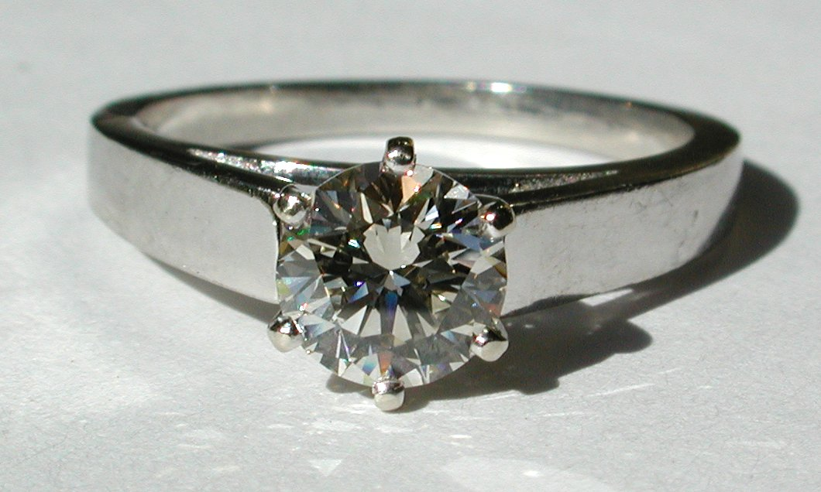

Cash Price: $19,999

Hire purchase: Deposit 20%

Insurance fee $35

Interest 25%

Pay over 4 years

Monthly payments:

How much extra does the hire purchase cost:



Cash Price: $45990

Hire Purchase: Deposit 15%

Insurance fee $20

Interest 35%

Pay over 5 years

Monthly payments:

How much extra does the hire purchase cost:

Cash Price: $349

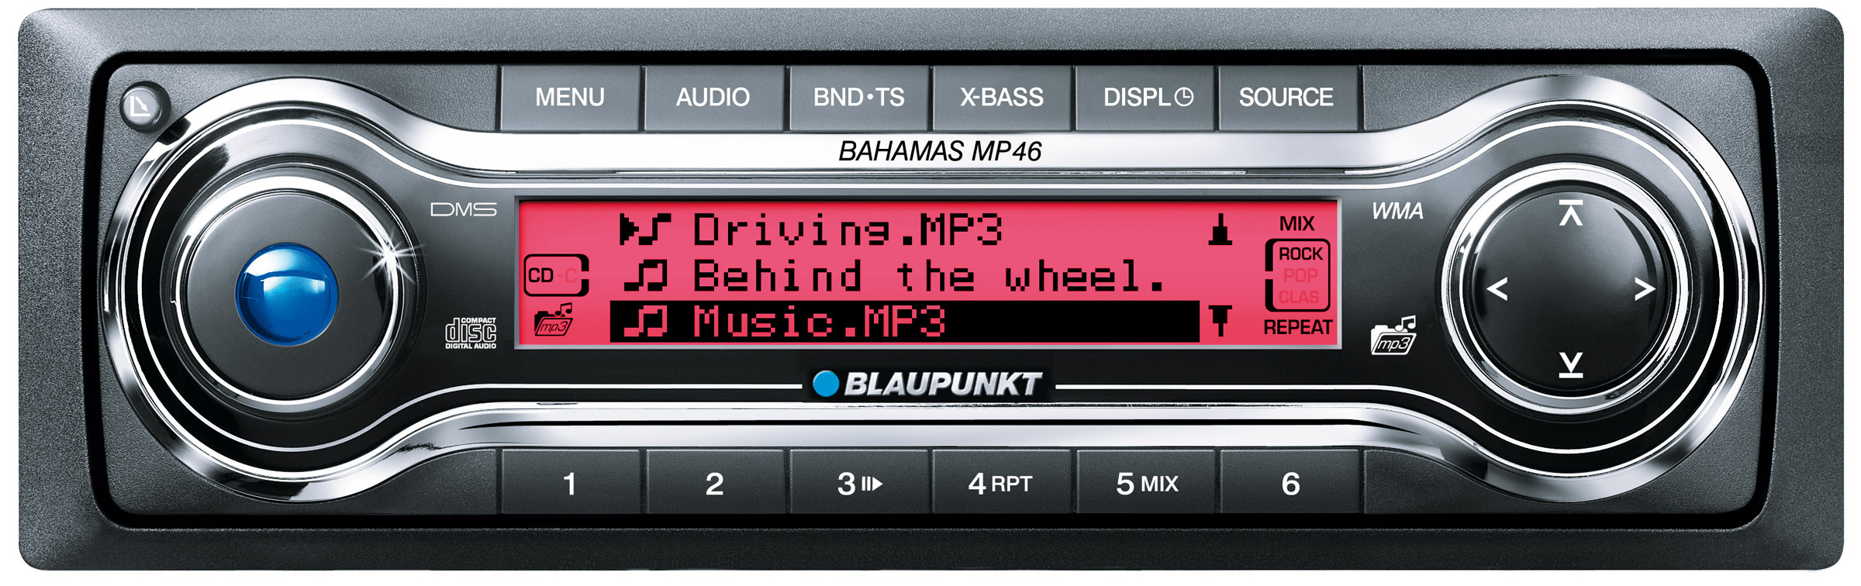

Hire Purchase: Deposit 10%

Insurance fee $35

Interest 15%

6 months to pay

Monthly payments:

How much extra does the hire purchase cost:



Cash Price: $1200

Hire Purchase: Deposit 25%

Insurance fee $45

Interest 20%

3 years to pay

Monthly payments:

How much extra does the hire purchase cost:

Cash Price: $3299



Hire Purchase: Deposit 10%

Insurance Fee $35

Interest 30%

4 years to pay

Monthly payments:

How much extra does the hire purchase cost: