**. Proportion .**

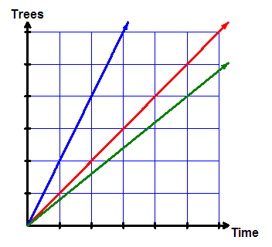

**6 sheep take 18 minutes to shear.**

**How long will 12 sheep take?**

**How long will 200 sheep take?**

**Direct proportion:**

**As one thing increases, so does another**

**Inverse proportion:**

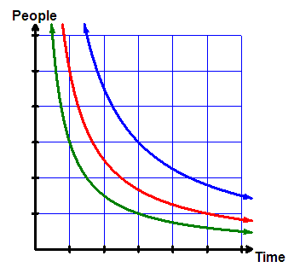

**A as one thing increases, another decreases**

**6 workers take 12hr to dig a ditch.**

**How long will 15 workers take?**

**Hints:**

**What is the value of 1 item**

**Estimate the value of 1 item – will it be more or less? Do we divide or multiply?**

**Estimate the answer – will it be more or less? Do we divide or multiply?**

**. Proportion Examples .**

|  |  |
| --- | --- |
| **Direct Proportion: As one quantity increases so does the other** | |
| **Example 1** | **eg. It takes a person 6 minutes to harvest the apples from a tree How long will it take to harvest 20 trees? (assume trees similar)** |
| **(multiply) More trees = More time** | **1 person = 1 tree = 6 minutes 1 person = 20 trees = 6 x 20 = 120 minutes (2hr)  Answer = 120 minutes (2hr)** |
| **Inverse Proportion: As one quantity increases the other decreases** | |
| **Example 2** | **eg. It takes a person 48 minutes to harvest a row of apple trees How long will it take 4 people to harvest a row? (assume rows similar)** |
| **Given** | **1 person = 1 row = 48 minutes** |
| **(divide) More people = Less time** | **4 people = 1 row = 48 ÷ 4 = 12 minutes Answer = 12 minutes** |

**. Combined Problems .**

|  |  |
| --- | --- |
| **Example 3** | **eg. It takes 4 people 32 minutes to harvest 5 rows of pear trees How long will it take 2 people to harvest 4 rows? (assume rows similar)** |
|  |  |
| **Information given** | **4 people = 5 rows = 32 minutes** |
| **Less people = More time** | **2 people = 5 rows = 64 minutes** |
| **Less rows = Less time** | **2 people = 1 row = 12.8 minutes** |
| **More rows = More time** | **2 people = 4 rows = 51.2 minutes** |
|  | **Answer = 51.2 minutes** |

**. Combined Problems .**

|  |  |
| --- | --- |
| **Example 4** | **eg. It takes 8 people 35 minutes to harvest a 6 rows of apricot trees. 5 people have 2hr of time available.  How many rows can they harvest? (assume rows similar)** |
| **Information given** | **8 people = 6 rows = 35 minutes** |
| **Less people = More time** | **1 person = 6 rows = 280 minutes** |
| **More people = Less time** | **5 people = 6 rows = 56 minutes** |
| **Less time = Less rows** | **5 people = 6/56 rows = 1 minute** |
| **More time = More rows** | **5 people = 12.857 rows = 120 minutes** |
|  | **Answer = 12.9 rows (almost thirteen)** |