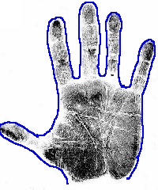
Area

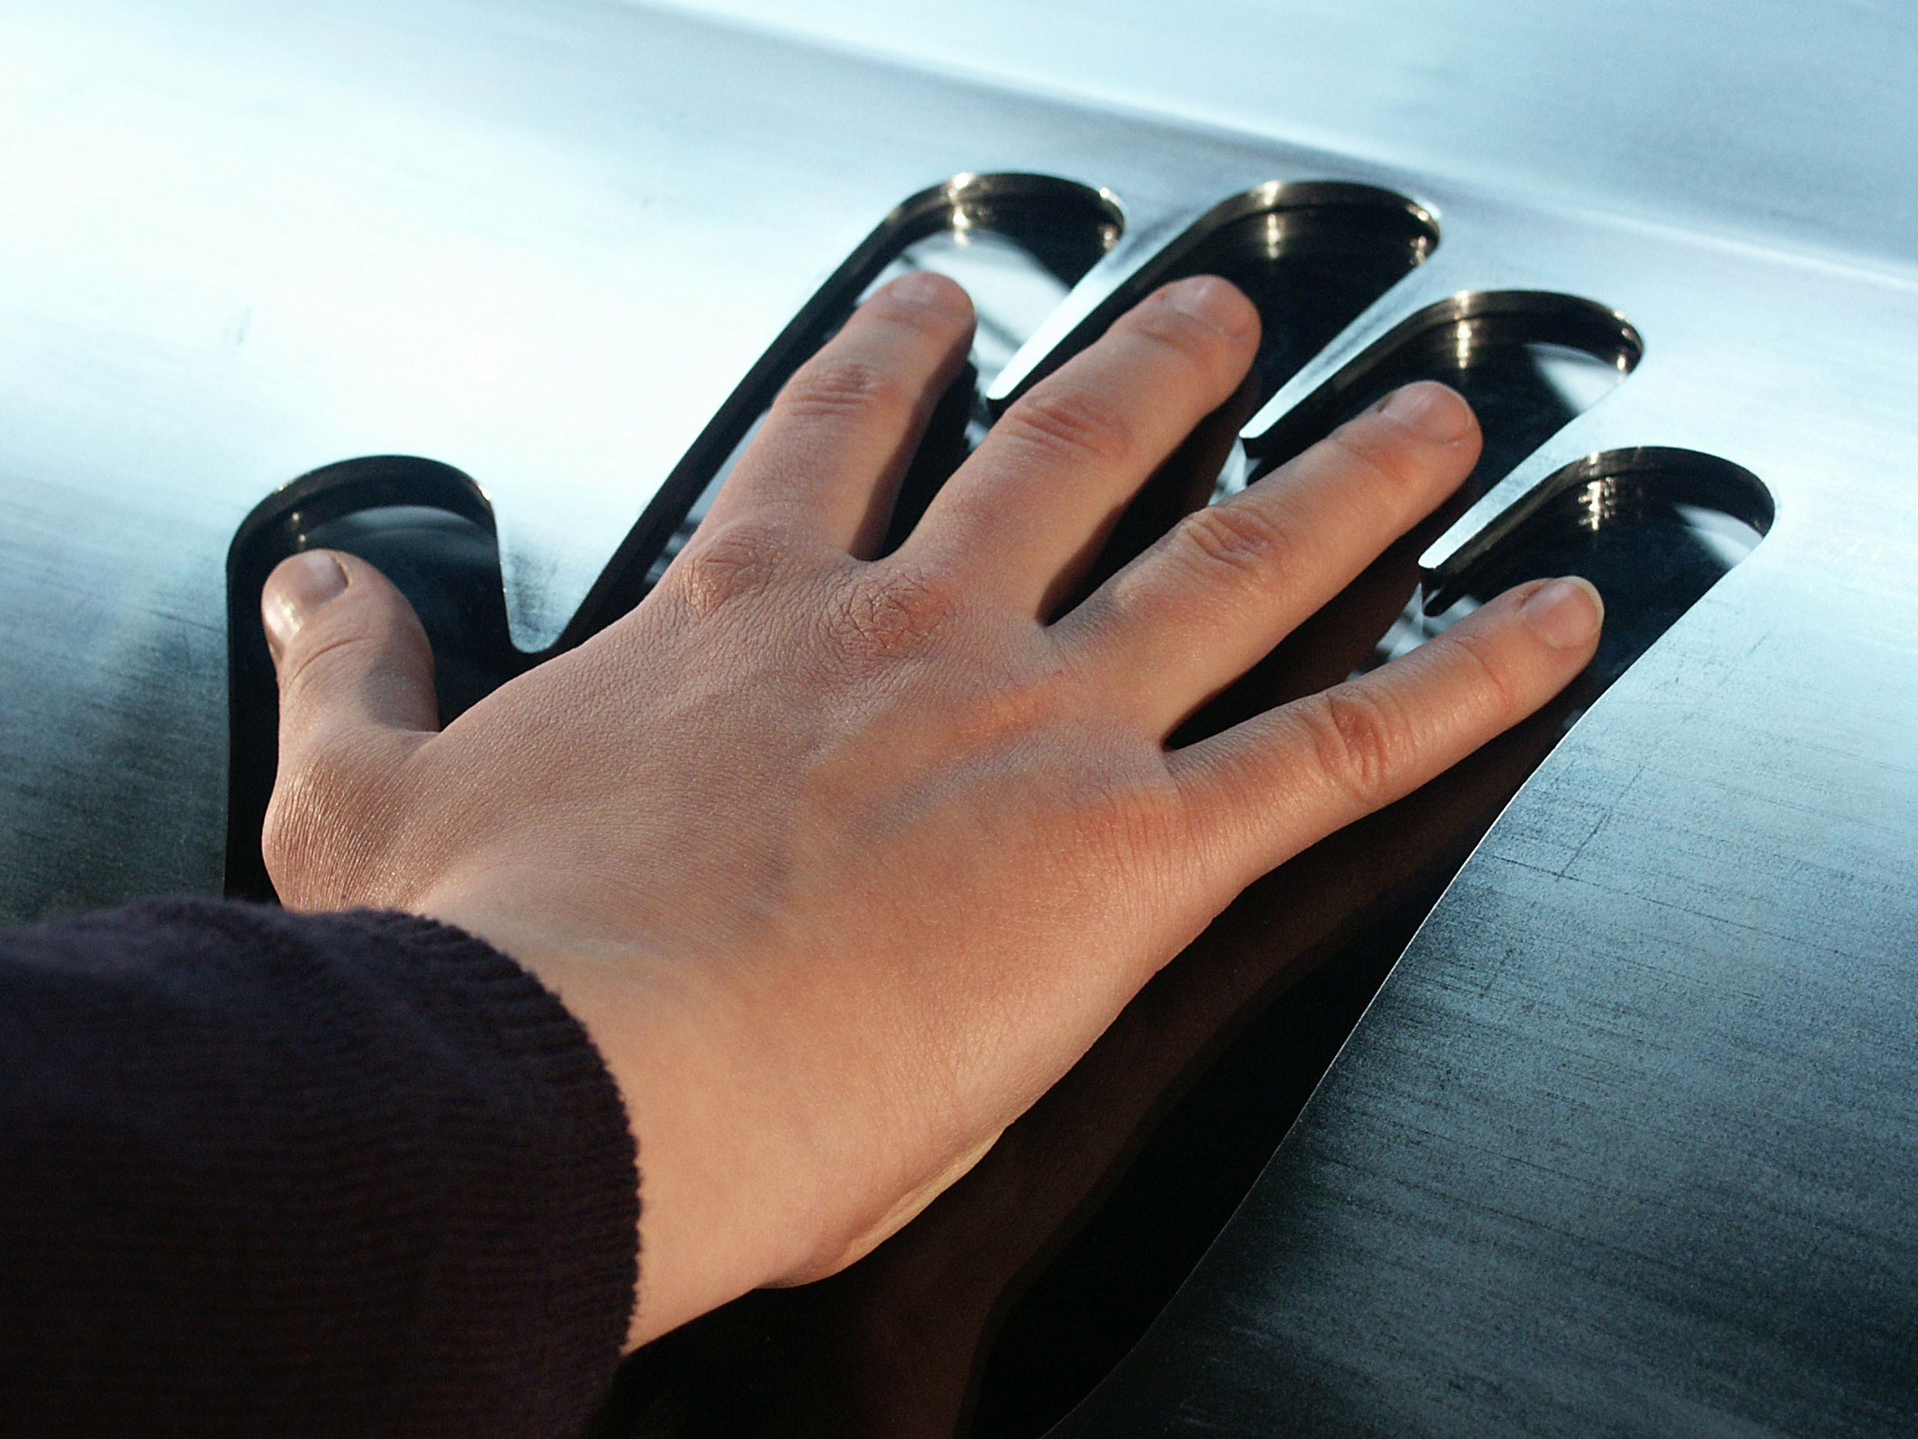
Draw an outline of your palm
What is your palm area?
Is there a faster way of
calculating the area?
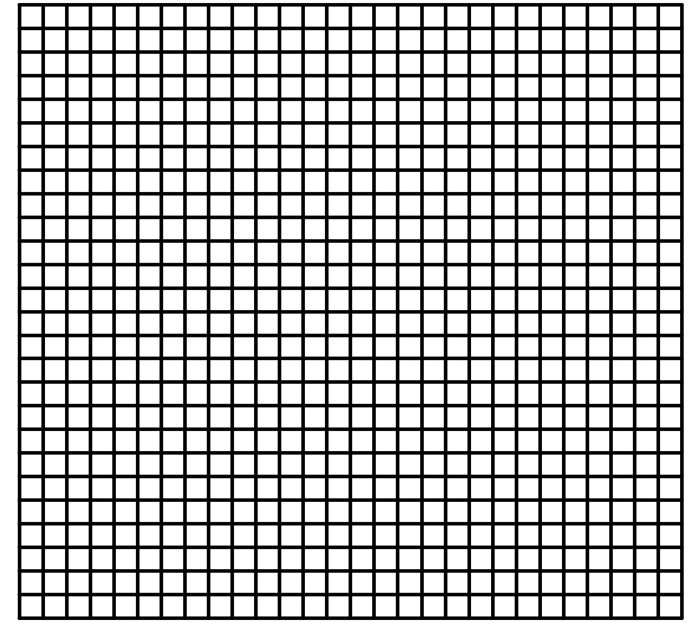

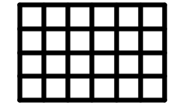
Rectangles
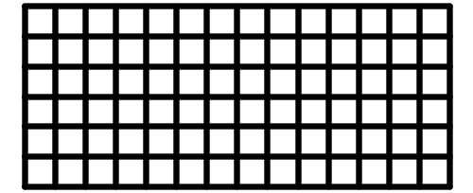
How many paving stones?
Height h
Base b
Area = ………………………………….
Perimeter = ……………………………….
Examples
Perimeter =……+…..+…..+…..= ……… m
Working Answer Units
5m
8m
Area = ……… = ……….m²
Working Answer units
1)
2.2cm
1.4cm
Area = Perimeter =
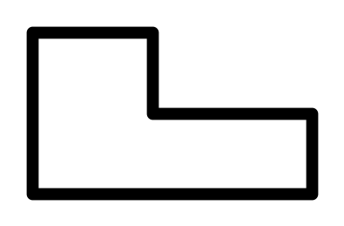
2.8 m
2.2 m
1.4 m
2) Area =
Perimeter =
1 m

1) Area =……………… perimeter = ……………….
25cm
16cm
Rectangles: Practice
=……………… = ……………….
6m
10m
7m
14m
? ___m
4m

2)
Area =……………………………………….

Perimeter = ………………………………
48 cm²
6 cm
? m
3) Perimeter = ………………………………

Alpha:
pg.174 Ex 11.1
pg.176 Ex 11.2
pg.176 Ex 11.2

Rectangles: Investigation
1) If a rectangle has an area of 48(cm² or squares)
and all sides can only be whole number lengths…
- How many different rectangles are possible?
- How do you know you have all possible rectangles?
- Investigate how the perimeter changes for each rectangle
- How can this pattern be shown on a graph?

Height h
Base b
Area of a Triangle

Rule: ………………………………………….

Examples
6m
8m
10m
Perimeter = ……………………………………….
Working Answer units
Area = ……………………………………..…
Working Answer units

2.2cm
1.8cm
2.8cm
2.8cm
Perimeter = ……………………………………….
Working Answer units

Area = ……………………………………..…
Working Answer units

24m
10m
26m
Triangles: Practice
1) Area =………………. perimeter = ……………….
= …………….. = ………………
2.4m
1.2m
5.5m
8.4m
3.2m

2) Area =………………. perimeter = ……………….
= …………….. = ………………

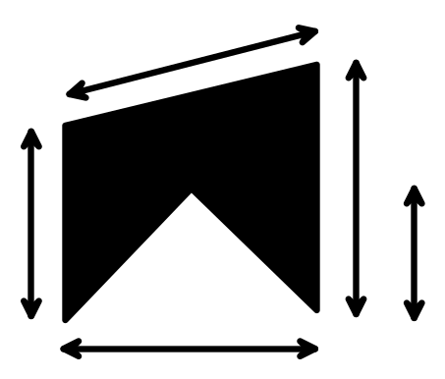
8cm
19cm
10cm
15cm
12cm
3) Area =………………. perimeter = ……………….
= …………….. = ………………

Text Practice:
Alpha pg.179 Ex 11.3
Must # 1-12 Extn 13,14

Triangles: Investigation A
1) If a triangle has longest side of 5 (cm or squares)
and all sides can only be whole number lengths…
- How many different triangles are possible?
- How do you know you have all possible triangles?

2) For any given longest side can you predict the number of possible triangles?

3) What types of triangles can be drawn with a particular longest side?
- How many equilateral triangles?
- How many isosceles triangles?
- How many scalene triangles?
- Is it possible to get a right angle triangle?

Triangles: Investigation B
4) Consider the perimeter of the triangles
- How many different perimeters are possible for a particular longest side?
- For a particular longest side can you predict the maximum perimeter?
And the minimum perimeter?

5) Consider the areas of triangles
- For a particular longest side can you predict the maximum area?
- Is it possible for the area to equal the perimeter? (ignore units)

